**CHAPTER TWO**

**LITERATURE REVIEW**

**2.1 History of Machine Learning**

Right from the onset of evolution, humans have been using many types of tools to accomplish various tasks. The intelligence and creativity of the human brain led to the invention of many different machines. These machines helped make the life of humans easy by enabling people to meet various life needs, including traveling, industries, constructions, and computing. Despite the rapid and successful developments in the machine industry, intelligence has remained the fundamental difference between humans and machines in performing tasks. A human makes use of his or her five senses to gather information or stimuli from the surrounding atmosphere; the human brain works to analyze that information and takes suitable decisions accordingly. Machines, on the other hand, are not intelligent by nature. A machine lacks the ability to analyze data and take decisions. For example, a machine is not capable or expected to understand the story of Harry Potter or a James Bond movie, jump over a hole in the street, or interact with other machines through a common language. The era of intelligent machines began in the mid-twentieth century when Alan Turing thought whether it is possible for machines to think. Ever since then, the artificial intelligence (AI) branch of computer science has developed rapidly over the past few decades. Humans have had the dream and the zeal to create machines that have the same level of intelligence as humans. Many science fiction movies have expressed these dreams about Artificial Intelligence; The Matrix; The Terminator; I, Robot; and Star Wars.

According to (Tandara and Barvick, 2014), The history of AI started in the year 1943 when Waren McCulloch and Walter Pitts introduced the first neural network model. Alan Turing introduced the next noticeable work in the development of the AI in 1950 when he asked his famous question: can machines think? He introduced the B-type neural networks and also the concept of test of intelligence. In 1955, Oliver Selfridge proposed the use of computers for pattern recognition. In 1956, John McCarthy, Marvin Minsky, Nathan Rochester of IBM, and Claude Shannon organized the first summer AI conference at Dartmouth College, the United States. In the second Dartmouth conference, the term artificial intelligence was used for the first time. The term cognitive science originated in 1956, during a symposium in information science at the MIT, the United States (Bashier 2016).

Rosenblatt invented the first perceptron in 1957. Then in 1959, John McCarthy invented the LISP programming language. David Hubel and Torsten Wiesel proposed the use of neural networks for the computer vision in 1962. Joseph Weizenbaum developed the first expert system which was called Eliza that could diagnose a disease based on its symptoms. The National Research Council (NRC) of the United States founded the Automatic Language Processing Advisory Committee (ALPAC) in 1964 to advance the research in the natural language processing. But after many years, the two organizations terminated the research because of the high expenses and low progress. Marvin Minsky and Seymour Papert published their book Perceptrons in 1969, in which they demonstrated the limitations of neural networks. As a result, organizations stopped funding research on neural networks. The period from 1969 to 1979 witnessed a growth in the research of knowledge based systems. The programs Dendral and Mycin are examples of this research. In 1979, Paul Werbos proposed the first efficient neural network model with backpropagation. However, in 1986, David Rumelhart, Geoffrey Hinton, and Ronald Williams discovered a method that allowed a network to learn to discriminate between nonlinear separable classes, and they named it back propagation (Weizenbaum 2017).

In 1987, Terrence Sejnowski and Charles Rosenberg developed an artificial neural network NETTalk for speech recognition. In 1987, John H. Holland and Arthur W. Burks invented an adapted computing system that is capable of learning. In fact, the development of the theory and application of genetic algorithms was inspired by the book Adaptation in Neural and Artificial Systems, written by Holland in 1975. In 1989, Dean Pomerleau proposed ALVINN (autonomous land vehicle in a neural network), which was a three-layer neural network designed for the task of the road following (Gary 2011). In the year 1997, the Deep Blue chess machine, designed by IBM, defeated Garry Kasparov, the world chess champion. In 2011, Watson, a computer developed by IBM, defeated Brad Rutter and Ken Jennings, the champions of the television game show Jeopardy! The period from 1997 to the present witnessed rapid developments in reinforcement learning, natural language processing, emotional understanding, computer vision, and computer hearing. The current research in machine learning focuses on computer vision, hearing, natural languages processing, image processing and pattern recognition, cognitive computing, knowledge representation, and so on. These research trends aim to provide machines with the abilities of gathering data through senses similar to the human senses and then processing the gathered data by using the computational intelligence tools and machine learning methods to conduct predictions and making decisions at the same level as humans. The term machine learning means to enable machines to learn without programming them explicitly.

**2.2 The Study of Machine Learning**

According to Durant (1929), Learning is a very personalized phenomenon for us. Will Durant in his famous book, The Pleasures of Philosophy, wondered in the chapter titled “Is Man a Machine?” when he wrote such classical lines:

“*Here is a child; … See it raising itself for the first time, fearfully and bravely, to a vertical dignity; why should it long so to stand and walk? Why should it tremble with perpetual curiosity, with perilous and insatiable ambition, touching and tasting, watching and listening, manipulating and experimenting, observing and pondering, growing—till it weighs the earth and charts and measures the stars?”*

Nevertheless, learning is not limited to humans only. Even the simplest of species such as amoeba and paramecium exhibit this phenomenon. Plants also show intelligent behavior. Only nonliving things are the natural stuffs that are not involved in learning. Hence, it seems that living and learning go together. In nature-made nonliving things, there is hardly anything to learn. Can we introduce learning in human-made nonliving things that are called machines? Enabling a machine capable of learning like humans is a dream, the fulfilment of which can lead us to having deterministic machines with freedom (or illusion of freedom in a sense). During that time, we will be able to happily boast that our humanoids resemble the image and likeliness of humans in the guise of machines. Machines are by nature not intelligent. Initially, machines were designed to perform specific tasks, such as running on the railway, controlling the traffic, digging deep holes, traveling into the space, and shooting at moving objects. Machines do their tasks much faster with a higher level of precision compared to humans (Khan *et al.,* 2016). They have made our lives easy and smooth. The fundamental difference between humans and machines in performing their work is intelligence. The human brain receives data gathered by the five senses: vision, hearing, smell, taste, and tactility. These gathered data are sent to the human brain via the neural system for perception and taking action. In the perception process, the data is organized, recognized by comparing it to previous experiences that were stored in the memory, and interpreted. Accordingly, the brain takes the decision and directs the body parts to react against that action. At the end of the experience, it might be stored in the memory for future benefits. A machine cannot deal with the gathered data in an intelligent way. It does not have the ability to analyze data for classification, benefit from previous experiences, and store the new experiences to the memory units; that is, machines do not learn from experience. Although machines are expected to do mechanical jobs much faster than humans, it is not expected from a machine to: understand the play Romeo and Juliet, jump over a hole in the street, form friendships, interact with other machines through a common language, recognize dangers and the ways to avoid them, decide about a disease from its symptoms and laboratory tests, recognize the face of the criminal, and so on. The challenge is to make dumb machines learn to cope correctly with such situations. Because machines have been originally created to help humans in their daily lives, it is necessary for the machines to think, understand to solve problems, and take suitable decisions akin to humans.

Machine learning is a branch of artificial intelligence that aims to equip machines with the ability to perform their jobs skillfully by using intelligent software. The statistical learning methods forms the backbone of intelligent software that is used to develop intelligent machines. Because machine learning algorithms need data to learn, the discipline must have connection with the discipline of database. Similarly, there are familiar terms such as Knowledge Discovery from Data (KDD), data mining, and pattern recognition (Asahd and Mohssen, 2018).

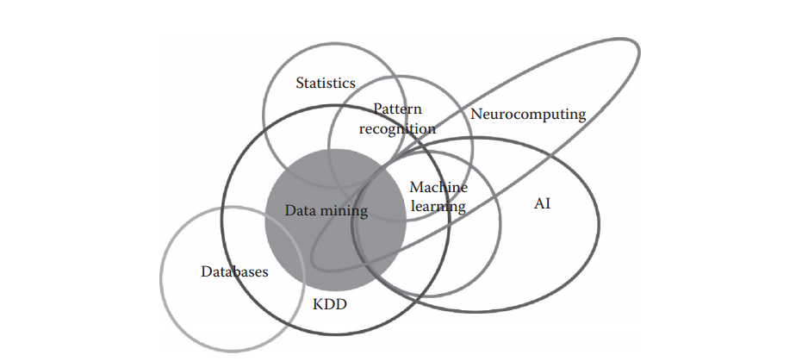

Fig 2.1 Machine Learning: Where Several Disciplines meet.

*Source:* [*http://blogs.sas.com/content/subconsciousmusings/2014/08/22/looking-backwards-lookingforwards-sas-data-mining-and-machine-learning/2014*](http://blogs.sas.com/content/subconsciousmusings/2014/08/22/looking-backwards-lookingforwards-sas-data-mining-and-machine-learning/2014)*.*

Machine Learning is an intersection of Computer Science and Statistics. We might say the outright question of Computer Science is ‘How can we build intelligent machines that can solve problems, and which problems are inherently amenable/non-amenable?’ The question that particularly defines Statistics is ‘What can be inferred from a given data plus a set of modeling assumptions and with what accuracy?’ Machine Learning integrates additional questions about what computational architectures and algorithms can be used to most effectively capture, store, index, retrieve and merge these data, how multiple learning subtasks can be orchestrated in a larger system, and questions of computational tractability (Junaid 2011).

There are some tasks that humans perform effortlessly or with some efforts, but we are unable to explain how we perform them. For example, we can recognize the speech of our friends without much difficulty. If we are asked how we recognize the voices, the answer is very difficult for us to explain. Because of the lack of understanding of such phenomenon (speech recognition in this case), we cannot craft algorithms for such scenarios. Machine learning algorithms are helpful in bridging this gap of understanding. The idea is very simple. We are not targeting to understand the underlying processes that help us learn. We write computer programs that enables machines learn and enables them to perform tasks, such as prediction. The goal of learning is to construct a model that takes the input and produces the desired result. Sometimes, we can understand the model, whereas, at other times, it can also be like a black box for us, the working of which cannot be intuitively explained (Asahd and Mohssen, 2018). The model can be considered as an approximation of the process we want machines to mimic. In such a situation, it is possible that we obtain errors for some input, but most of the time, the model provides correct answers. Hence, another measure of performance (besides performance of metrics of speed and memory usage) of a machine learning algorithm will be the accuracy of results.

**2.3 Machine Learning Techniques and Required Data**

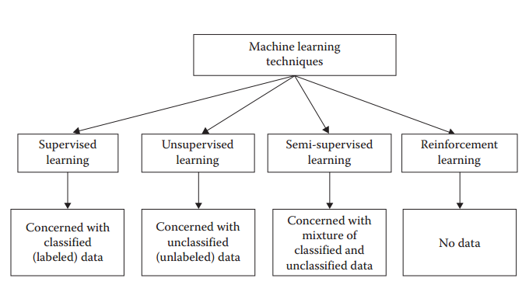

Fig 2.2 Different machine learning techniques and their required data.

*Source: https:www.aiworld/home/ml*

There are four general machine learning methods: supervised, unsupervised, semi-supervised, and reinforcement learning methods. The objectives of machine learning techniques are to enable machines to make predictions, perform clustering, extract association rules, or make decisions from a given dataset.

In supervised learning, the target is to infer a function or mapping from training data that is labeled. The training data consist of input vector X and output vector Y of labels or tags. A label or tag from vector Y is the explanation of its respective input example from input vector X. Together they form a training example. In other words, training data comprises training examples. If the labeling does not exist for input vector X, then X is unlabeled data. Why such learning is called supervised learning? The output vector Y consists of labels for each training example present in the training data. These labels for output vector are provided by the supervisor. Often, these supervisors are humans, but machines can also be used for such labeling. Human judgments are more expensive than machines, but the higher error rates in data labeled by machines suggest superiority of human judgment. The manually labeled data is a precious and reliable resource for supervised learning. However, in some cases, machines can be used for reliable labeling.

**2.4 Supervised Machine Learning**

Supervised Learning are the ones that involve direct supervision of the operation. In this case, the programmer labels sample data and sets strict parameters upon which the algorithm operates. It is a spoon-fed version of machine learning: you select what kind of information output (samples) to “feed” the algorithm and what kind of results it is desired (for example “yes/no” or “true/false”). From the machine’s point of view, this process becomes more or less like a game or a “connect the dots” routine. The primary purpose of supervised learning algorithms is to scale the scope of data and to make predictions of unavailable, future or unseen data based on labeled sample data (Bilyk,2012)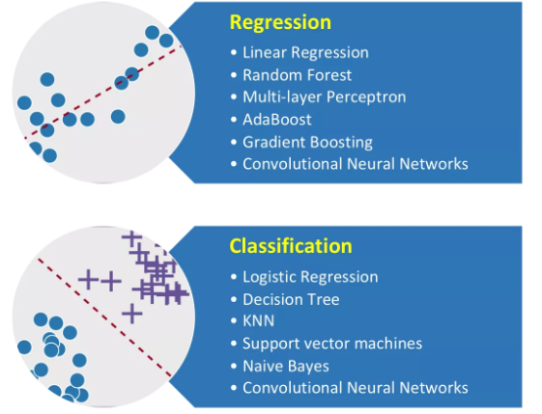

Fig 2.3 Machine Learning Algorithms

*Source:* [*https://vinodsblog.com/2018/03/26/machine-learning-introduction-to-its-algorithms-mlalgos/*](https://vinodsblog.com/2018/03/26/machine-learning-introduction-to-its-algorithms-mlalgos/)

**• Classification:** It predicts the category the data belongs to e.g.: Spam Detection, Churn Prediction, Sentiment Analysis, Dog Breed Detection, etc.

• **Regressio**n: It predicts a numerical value based on previous observed data. e.g.: House Price Prediction, Stock Price Prediction, Height-Weight Prediction, etc.

The process of the supervised machine learning algorithm learning from the training dataset can be thought of as a teacher overseeing/supervising the learning process. We already know the correct answers so the algorithm iteratively makes predictions on the training data it has been given and is corrected by the teacher. Learning can be stopped when the algorithm performs satisfactorily and achieves an acceptable level of performance. In Supervised Learning, the algorithms learn from already labeled data. After understanding the data, the algorithm determines which label should be given to new data based on pattern and associating the patterns to the unlabeled new data. Supervised machine learning is a type of system in which both input and desired output data are provided. Input and output data are well labeled for classification to provide a learning basis for future data processing. Supervised Learning is divided into two categories i.e. Classification & Regression.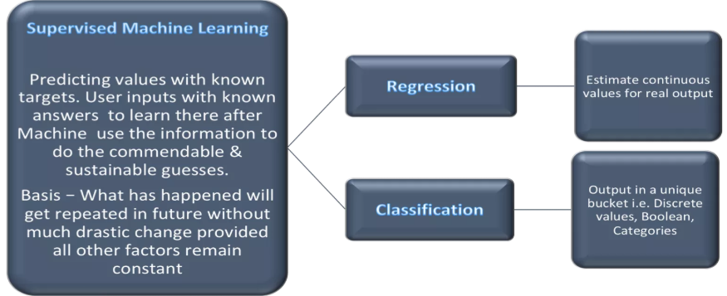

Fig 2.4 Supervised machine learning and its branches

*Source: https://vinodsblog.com/2018/04/02/supervised-machine-learning-insider-scoop-for-labeled-data/*

**2.4.1 The Supervised Machine Learning Process**

While there are numerous machine learning algorithms for supervised learning, most of them employ the same basic work flow for obtaining a predictor model. The accuracy of the supervised learning process is determined by the number of correct classification divided by the total number of test cases. This equation clearly shows accuracy will be more close to perfection when we have when the difference between “number of correct classification” and “number of test cases” is minimal. The process for Supervised Machine Learning is basically a two-way process as below.

* Learning – Learn a model using the training data or train model using training data.
* Testing – Test the model using unseen test data to assess the model accuracy

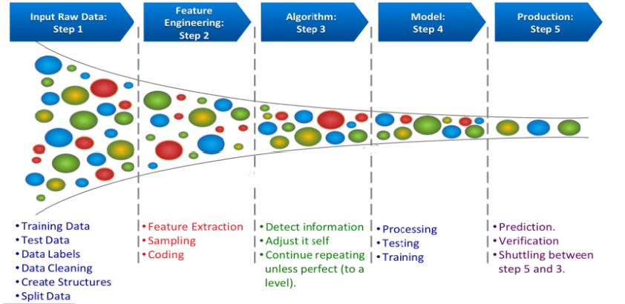

Fig 2.5 Supervised machine learning process

*Source:* *https://towardsdatascience.com/supervised-machine-learning-classification-*

1. Prepare data
2. Choose an algorithm
3. Fit a model
4. Choose a validation method
5. Examine fit and update until satisfied
6. Use the fitted model for predictions

The detailed steps for supervised learning processes are included but not limited with pointers as above.

**2.5 Convolutional Neural Networks in Image Analysis**

Convolutional neural networks are a machine learning algorithm that is used primarily to classify images (by naming what they see), cluster them by resemblance and similarity (photo search), and perform detailed object recognition within scenes. They are algorithms that can spot and identify faces, objects, street signs, plants, tumors, platypuses and many other aspects of visual data. The efficacy of convolutional neural networks (CNNs) in image recognition is one of the main reasons why the world has woken up to the efficacy of deep learning. They are the backbone of major breakthroughs in computer vision, which has applications in self-driving vehicles, robotics, drones, security cameras, medical diagnosis, and treatments for the visually impaired.

**2.5.1 The Input Image**

From the Latin convolvere, “to convolve” means to roll together. For mathematical purposes, a convolution is the integral measuring how much two functions overlap as one passes over the other. A convolutional neural network (CNN) is a type of artificial neural network used in image recognition and processing that is specifically designed to process pixel data. Convolutional neural networks ingest and process images as tensors, and tensors are matrices of numbers with additional dimensions (. They can be hard to visualize, so let’s approach them by analogy. A scalar is just a number, such as 7; a vector is a list of numbers (e.g., [7,8,9]); and a matrix is a rectangular grid of numbers occupying several rows and columns like a spreadsheet (Rouse et al., 2015). Geometrically, if a scalar is a zero-dimensional point, then a vector is a one-dimensional line, a matrix is a two-dimensional plane, a stack of matrices is a three-dimensional cube, and when each element of those matrices has a stack of feature maps attached to it, you enter the fourth dimension. For reference, here’s a 2 x 2 matrix:

[ 1, 2 ]

[ 5, 8 ]

A tensor encompasses the dimensions beyond that 2-D plane. You can easily picture a three-dimensional tensor, with the array of numbers arranged in a cube. Here’s a 2 x 3 x 2 tensor presented flatly (picture the bottom element of each 2-element array extending along the z-axis to intuitively grasp why it’s called a 3-dimensional array)

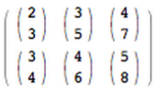

In code, the tensor above would appear like this: [[[2,3],[3,5],[4,7]],[[3,4],[4,6],[5,8]]]. And here’s a visual:

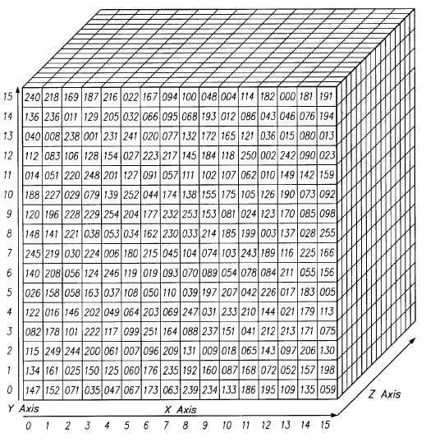

Fig 2.6 A scalar representation of an image

*Source:* [*https://skymind.ai/wiki/convolutional-network*](https://skymind.ai/wiki/convolutional-network)

In other words, tensors are formed by arrays nested within arrays, and that nesting can go on infinitely, accounting for an arbitrary number of dimensions far greater than what we can visualize spatially. A 4-D tensor would simply replace each of these scalars with an array nested one level deeper. Convolutional networks deal in 4-D tensors like the one below (notice the nested array).

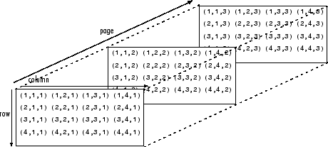

Fig 2.7 The three layers of an image (Red-Green-Blue)

*Source: https://skymind.ai/wiki/convolutional-network*

The first thing to know about convolutional networks is that they don’t perceive images like humans do. Therefore, you are going to have to think in a different way about what an image means as it is fed to and processed by a convolutional network.

Convolutional networks perceive images as volumes; i.e. three-dimensional objects, rather than flat canvases to be measured only by width and height. That’s because digital color images have a red-blue-green (RGB) encoding, mixing those three colors to produce the color spectrum humans perceive. A convolutional network ingests such images as three separate strata of color stacked one on top of the other. So a convolutional network receives a normal color image as a rectangular box whose width and height are measured by the number of pixels along those dimensions, and whose depth is three layers deep, one for each letter in RGB. Those depth layers are referred to as channels. As images move through a convolutional network, we will describe them in terms of input and output volumes, expressing them mathematically as matrices of multiple dimensions in this form: 30x30x3. From layer to layer, their dimensions change for reasons that will be explained below. You will need to pay close attention to the precise measures of each dimension of the image volume, because they are the foundation of the linear algebra operations used to process images.

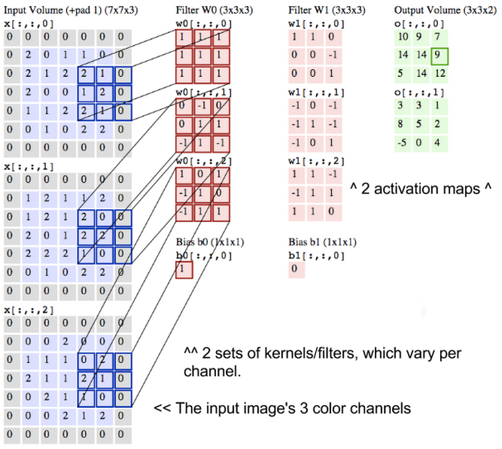

Fig 2.8 Convolutional operation on the three layers of an image(R-G-B)

*Source: https://skymind.ai/wiki/convolutional-network*

Now, for each pixel of an image, the intensity of R, G and B will be expressed by a number, and that number will be an element in one of the three, stacked two-dimensional matrices, which together form the image volume. Those numbers are the initial, raw, sensory features being fed into the convolutional network, and the CNN's purpose is to find which of those numbers are significant signals that actually help it classify images more accurately. Rather than focus on one pixel at a time, a convolutional net takes in square patches of pixels and passes them through a filter. That filter is also a square matrix smaller than the image itself, and equal in size to the patch. It is also called a kernel and the job of the filter is to find patterns in the pixels (Ruchibal 2014).

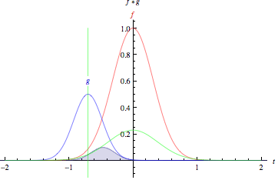

Fig 2.9 Graph showing convolution between the R-G-B images and how they overlap (1)

*Source:* [*http://mathworld.wolfram.com/*](http://mathworld.wolfram.com/)

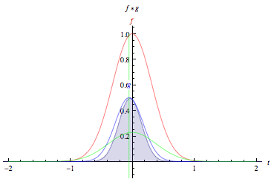

Fig 2.10 Graph showing convolution between the R-G-B images and how they overlap (2)

*Source:* [*http://mathworld.wolfram.com/*](http://mathworld.wolfram.com/)

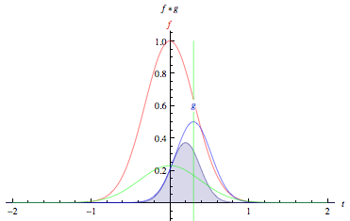

Fig 2.11 Graph showing convolution between the R-G-B images and how they overlap (3)

*Source:* [*http://mathworld.wolfram.com/*](http://mathworld.wolfram.com/)

*“The green curve shows the convolution of the blue and red curves as a function of t, the position indicated by the vertical green line. The gray region indicates the product g(tau)f(t-tau) as a function of t, so its area as a function of t is precisely the convolution.”*

Look at the tall, narrow bell curve standing in the middle of a graph. The integral is the area under that curve. Near it is a second bell curve that is shorter and wider, drifting slowly from the left side of the graph to the right. The product of those two functions’ overlap at each point along the x-axis is their convolution. So in a sense, the two functions are being “rolled together.”

What we just described is a convolution. You can think of Convolution as a kind of multiplication used in signal processing. Another way to think about the two matrices creating a dot product is as two functions. The image is the underlying function, and the filter is the function you roll over it.

**2.6 Application Areas of Machine Learning in Healthcare**

Machine learning is another field which is seeing gradual acceptance in the healthcare industry. Google recently developed a machine-learning algorithm to identify cancerous tumors in mammograms, and researchers in Stanford University are using deep learning to identify skin cancer. Machine Learning in healthcare helps to analyze and process thousands of different data and suggest outcomes, provide accurate and timely risk scores, precise resource allocation, and has many other applications (Mohammad 2017). Here are some applications of machine learning in healthcare:

1. Identifying Diseases and Diagnosis:

One of the chief machine learning applications in healthcare is the identification and diagnosis of diseases and ailments which are otherwise considered hard-to-diagnose. This can include anything from cancers which are tough to catch during the initial stages, to other genetic diseases.

2. Drug Discovery and Manufacturing:

One of the primary clinical applications of machine learning lies in early-stage drug discovery process. This also includes R&D technologies such as next-generation sequencing and precision medicine which can help in finding alternative paths for therapy of multifactorial diseases.



3. Medical Imaging Diagnosis: Machine learning and deep learning are both responsible for the breakthrough technology called Computer Vision. This has found acceptance in the Inner Eye initiative developed by Microsoft which works on image diagnostic tools for image analysis. Another example of this is the detection of malaria parasites in blood smears.

4. Outbreak Prediction:

AI-based technologies and machine learning are today also being put to use in monitoring and predicting epidemics around the world. Today, scientists have access to a large amount of data collected from satellites, real-time social media updates, website information, etc. Artificial neural networks help to collate this information and predict everything from malaria outbreaks to severe chronic infectious diseases. Predicting these outbreaks is especially helpful in third-world countries as they lack in crucial medical infrastructure and educational systems.

5. Personalized Medicine:

Personalized treatments can not only be more effective by pairing individual health with predictive analytics but is also ripe are for further research and better disease assessment. Currently, physicians are limited to choosing from a specific set of diagnoses or estimate the risk to the patient based on his symptomatic history and available genetic information.

**2.7 Advantages and Disadvantages of Machine Learning:**

Every coin has two faces and each face has its own property and features. It’s time to uncover the faces of Machine Learning which is a very powerful tool that holds the potential to revolutionize the way things work.

Advantages of Machine learning include but are not limited to the following;

1. **Easily identifies trends and patterns:** Machine Learning can review large volumes of data and discover specific trends and patterns that would not be apparent to humans.
2. **No human intervention needed (automation):** With ML, you don’t need to babysit your project every step of the way. Since it means giving machines the ability to learn, it lets them make predictions and also improve the algorithms on their own.
3. **Continuous Improvement:** As ML algorithms gain experience, they keep improving in accuracy and efficiency. This lets them make better decisions.
4. **Multi-dimensional and multi-variety data:** Machine Learning algorithms are good at handling data that are multi-dimensional and multi-variety, and they can do this in dynamic or uncertain environments.
5. **Wide Applications:** You could be an e-tailer, scientist or a healthcare provider and make ML work for you. Where it does apply, it holds the capability to help deliver a much more personal experience to customers while also targeting the right customers.

Disadvantages of Machine learning include:

1. **Data Acquisition:** Machine Learning requires massive data sets to train on, and these should be inclusive/unbiased, and of good quality.
2. **Time and Resources:** ML needs enough time to let the algorithms learn and develop enough to fulfill their purpose with a considerable amount of accuracy and relevancy. It also needs massive resources to function. This can mean additional requirements of computer power for you.
3. **Interpretation of Results:** Another major challenge is the ability to accurately interpret results generated by the algorithms. You must also carefully choose the algorithms for your purpose.
4. **High error-susceptibility:** Machine Learning is autonomous but highly susceptible to errors. Suppose you train an algorithm with data sets small enough to not be inclusive. You end up with biased predictions coming from a biased training set.